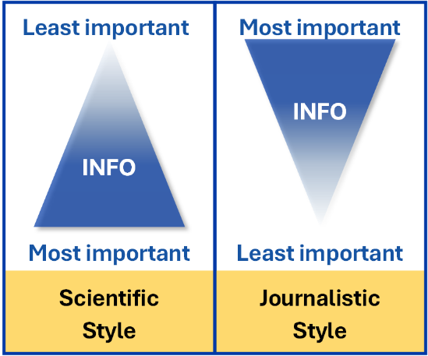
Academic Curriculum Vitae (CV) Guide
The curriculum vitae (CV) is a marketing tool used when applying for academic positions, grants, and awards, which details your credentials and professional accomplishments. The goal of a CV is to establish your scholarly identity and to showcase your abilities as an educator, scholar, and leader. The CV is a living document that should be continuously updated as your career progresses so that it remains a complete record of your professional career.
A CV contains your entire professional history and is more detailed and significantly longer than the traditional résumé. A résumé is at most 2 pages; although there is no page limit for a CV, it should be well-crafted and concise. The main body of the CV is typically 3–5 pages, though it will become longer as you acquire more experience.
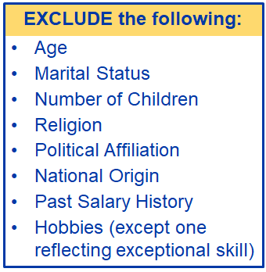
Despite the difference in length, CVs and résumés are both written using the journalistic style, with the most important information at the beginning. The order of sections is flexible, so arrange the sections with your most relevant experience at the top. For example, if you are applying to a four-year college where your main responsibility would be teaching, then your teaching experience should come before your research experience. If you are applying to research-intensive universities, your research experience should be presented first.
Not all positions in higher education require a CV. If specified, be sure to send the document requested! When using your CV to make a résumé, be sure to keep it to two pages by including only the most relevant information (experiences, skills, presentations, etc.) and by adding a headline statement (also called an executive summary or objective) with the top 3–5 bullet points proving that you are the best person for the job. Résumés emphasize skills and accomplishments—describing what you did and what the results were.
Even though there is no set structure for a CV, the sections listed below are typically included. Some information is never appropriate to include on a CV or résumé for a position in the United States, and headshots (and other pictures or graphics) do not belong on your CV either to prevent discrimination. You may format your CV however you like, but make sure the formatting is consistent, attractive, and (most importantly) easy to read.
Section Heading & Information to Include | Example
Personal information  Name, telephone number, LinkedIn profile address, and e-mail address. Including a mailing address is discouraged. | Alice Walker, Ph.D.  (555) 555-5555 • www.linkedin.com/in/alicewalker • awalker@gmail.com
Education  Degrees earned with dates awarded, granting institutions, thesis title(s) and advisor(s). If you are close but have not yet earned the degree, use “expected 20XX.” You could include other certifications or training in this section or add them to a new section. | Doctor of Philosophy, Chemistry 20XX  Master of Science, Chemistry 20XX  University A St. Somewhere, CA  - Thesis: “Sequence-Specific Recognition of DNA in the Minor Groove by Imidazole and Pyrrole-Containing Polyamides”  - Advisor: Bernard Jones, Ph.D.
Research experience  Position title, organization, dates employed, and bullet points that describe what you set out to accomplish, the importance of the work, and the responsibilities, skills, and major achievements you obtained. Research experience could be acquired during postdoc, graduate, undergraduate research experiences; industry positions; internships; or any other research-related position. | Postdoctoral Researcher 20XX–Present  University B, Department of Chemical Engineering Smallville, MA  Advisor: J. Smith  - Developed methodology for RNA-encapsulation in nanosphere particles using synthesized biodegradable polymers for ultimate use in gene therapy applications to combat incurable diseases  - Characterized materials using transmission electron microscopy, dynamic light scattering, and inductively coupled plasma mass spectrometry  - Resulted in a publication in ACS Chem. J.
Teaching experience  Position title, organization, dates employed, and bullet points that summarize responsibilities, skills, and major achievements. Experience could be acquired through professor, instructor/lecturer, and adjunct teaching positions; teaching postdocs; graduate and undergraduate teaching assistantships; tutoring experiences; or any other teaching-related position. You may turn bullet points into a paragraph. | Teaching Assistant, Organic Chemistry Lab 20XX  Teaching Assistant, General Chemistry Lab 20XX  University A, Department of Chemistry St. Somewhere, CA  - Supervised laboratory techniques for undergraduates consisting of typically 30 students per section  - Graded laboratory reports and provided personalized feedback to students  - Developed materials to hold “flipped” recitation sessions
Publications and patents  Complete citations for all publications (peer-reviewed papers, book chapters, etc.) and patents. You may include those works that have not yet been published but must include “submitted” or “under revision” with the name of the journal. | Walker, A.; Cummings, B.; Reynolds, J; Jones, B. Optimization of the Hairpin Polyamide Design for Recognition of the Minor Groove of DNA. J. Am. Chem. Soc., XXXX, 118(5), 1047–1056. DOI: 10.1021/jacs.1a012345
Presentations  Complete citations for presentations made at national, regional, and local meetings and conferences, as well as those given at other venues (e.g., university seminar series). Indicate whether presentation was a talk or poster, invited or contributed, and if you gave it. | Walker, A.; Cummings, B.; Reynolds, J; Jones, B. Recognition of 5’-(A,T)GG(A,T)2-3’ Sequences in the Minor Groove of DNA by Hairpin Polyamides. Presented at the Western Biotech/ACS Regional Conference, San Diego, CA, October XXXX; Contributed Talk.  Walker, A.; Brown, L.; Kinney, M.; Grey, P. Synthesis and DNA Binding Studies of Imidazole-Containing and Amidine-Linked Analogs of Distamycin A. Presented at the Fifth National Conference on Undergraduate Research, Pasadena, CA. April XXXX; Poster.
Honors and awards  Name of fellowships, honors and awards received, granting institutions, and years received. Give context for awards that are not easily recognizable. | Postdoctoral Fellowship, National Institutes of Health 20XX  Olaf T. Snow Award, University A 20XX  - For demonstrating outstanding potential for life-long contributions to field of chemistry (selected from 200 students).
Professional Affiliations  Organizations and dates of membership. Relevant organizations include ACS, AAAS, MRS, APS, NOBCChE, AWIS, SACNAS and more. Be sure to include held leadership positions or significant appointments. | American Chemical Society Member 20XX–Present  Treasurer, Smallville Section 20XX–20XX  Phi Beta Kappa 20XX–Present
Additional Sections
Additional sections can be included if the job position requires more information or as you acquire new experiences throughout your career. Examples of other CV sections include, but are not limited to:
- References: list of 3–4 professional references, including their full name, job title, institution name and address, and contact information (phone and email).
- Grants: include the project title, year submitted/awarded, principal investigators, granting institution, award amount, and your role if submitted as part of a team.
- Service: include service to university, department, profession/discipline, or community. For example, organizing a symposium, serving on a department or university committee (e.g., faculty senate), serving in a leadership position for an organization, supervising a student group, assisting with a special academic project, hosting an outreach event, etc.
- Students mentored: for each student mentored, list name, position (e.g., Yale University undergraduate student, University at Buffalo rotation student, etc.), when you mentored them, and their current status.
- Other experience: any other jobs or experiences that may be relevant including study abroad experience, training (e.g., pedagogical courses), certifications, fluent languages, etc.

Formatting Guidance
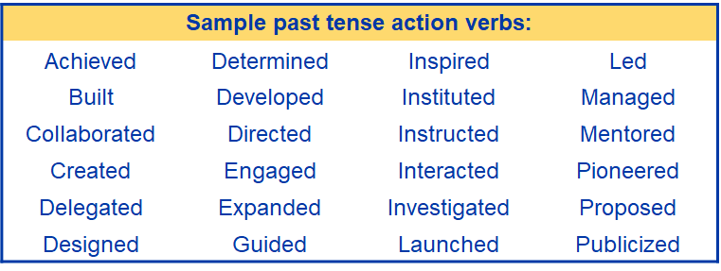
When formatting your resume, be sure to:
- include your last name and the page number on all pages of your CV.
- ALWAYS list information in each section in reverse chronological order.
- ALWAYS use past tense action verbs when detailing experiences, including for current position(s).
- refer to the ACS Style Guide for guidance.
- include keywords in these bulleted points instead of listing keywords in a separate section of your CV. Including keywords in descriptions of the experiences gives the reader context and is a much more valuable way to include them.
- spell out acronyms the first time they are used in your CV. Only use acronyms if they are used more than once.
You can choose to combine the publications, patents, and presentations sections into one, which is sometimes referred to as the Products section. Numbering your citations is optional.

Closing Thoughts
An example CV for a recent Ph.D. graduate is provided on the next pages. Remember that the CV is only one piece of your application portfolio. When applying for tenure-track positions in higher education, your portfolio should include your CV, customized cover letters, a list of professional references, your teaching philosophy and diversity statements, a research summary, and your notes about your elevator pitch.

The American Chemical Society offers its members the opportunity to arrange free one-on-one meetings with certified ACS Career Consultants, who will provide valuable feedback about your CV and other application portfolio documents. Visit https://www.acs.org/careers/personal-career-consulting.html for more details.

JAMES G. SPARROW
(555) 555-5555 • james.sparrow@mag.edu • www.linkedin.com/in/jamessparrow

Education
Doctor of Philosophy in Chemistry 20XX
Master of Science in Chemistry 20XX
University of Cloits Cloits, TX
- Thesis Title: “The Chemistry of Single Carbon Nanotube Optics and Electronics”
- Committee Chair and Research Advisor: Debrah Johnson, Ph. D.

Bachelor of Science in Chemistry, Summa Cum Laude 20XX
Wesson College Wesoon, TX

Research Experience
Postdoctoral Fellow 20XX–20XX
Magdellin Institute of Technology, Bioengineering Department Magdellin, VA
Advisor: Liu Cheng
- Led team of eight graduate and undergraduate students that developed chemical sensor based on nanomaterials to detect water and airborne chemical contaminants, chemical weapons agents, and toxic industrial chemicals.
- Established timeline criteria for project objectives. Scheduled and participated in meetings, appointments, and teleconferences with organizations, sub-contractors, and professional contacts.
- Analyzed experimental results and prepared reports to use in planning future experiments and to communicate project status to team members and stakeholders.
- Designed, purchased components for, and constructed brand new carbon nanotube (NT) facility to be used to synthesize materials for team and institute projects.
- Developed and refined methodology for synthesis of custom NT materials and high-concentration NT inks, and for analytical testing of sensors developed from such materials.

Graduate Chemistry Research Assistant 20XX–20XX
University of Cloits Cloits, TX
Advisor: Debrah Johnson
- Fabricated nano-sized circuits on silicon wafers using NTs as electrodes to form an electrical connection to a single nanoparticle to create nanocircuits. As part of the study, NT electrodes were synthesized using chemical vapor deposition techniques with different catalysts. Nano-circuits were fabricated with lithography equipment in a cleanroom environment; specifically, electron beam lithography was used to create <20 nm gaps in the NTs and where nanoparticles were deposited between the NT electrodes. Nanomaterials were characterized using absorption spectroscopy; atomic force, electrostatic force, and scanning electron microscopy; and electrical transport studies.
- Developed method to suspend NTs in aqueous solution for biological labeling using surfactants that resulted in solutions with better stability than standard protocols. Individual NTs were wrapped with surfactant X; the surfactant molecules were then cross-linked to provide a cage-structure that inhibited NT aggregation. UV/vis/NIR absorption and fluorescence studies confirmed the cross-linking of surfactant molecules and, importantly, that the NT suspensions retained their optical activity despite being aqueous. Resulted in publication in ACS Chem. J.
- In collaboration with the University of Cloits Medical Center, used atomic force microscopy to verify the presence of and to determine the concentration of fluorophore-labeled DNA tethered to silver substrates for use in fluorescent label-free DNA detection sensor studies. Resulted in a publication in ACS Chem. J.
- Served as group safety officer. Trained incoming group members on safety protocols, ensured safety measures were followed, answered safety-related questions, and disposed of hazardous waste.

JAMES G. SPARROW
Page 2

Teaching & Mentoring Experience
NSF Research Experience for Undergraduates (REU) Program Mentor 20XX and 20XX
University of Cloits, Chemistry Department Cloits, TX
- Mentored three undergraduate students on projects related to NT optics.
- Held individual meetings to help students in thinking critically to plan experiments for nanotechnology summer research projects, in learning how to use instrumentation and perform lab techniques properly, and in documenting data and observations appropriately in laboratory notebooks.
- Taught students how to analyze data and present results clearly in reports, posters, and oral presentations.

Graduate Teaching Assistant 20XX–20XX
University of Cloits, Chemistry Department Cloits, TX
- Moderated weekly inquiry-based workshops that highlighted important points in lecture material presented in general chemistry lectures.
- Assisted student experiments in physical chemistry laboratories, specifically covering molecular spectroscopy and chemical instrumentation methods. Helped to construct, maintain, and repair laboratory equipment; to grade full length laboratory reports; and to develop a teaching assistant’s manual that consisted of detailed pictures and descriptions of each experimental setup, sample data sets, and sample laboratory reports.

First Year Seminar Leader 20XX–20XX
University of Cloits, Chemistry Department Cloits, TX
- Helped professor and graduate student committee develop bimonthly seminar to help first year graduate students transition from undergraduate to graduate level coursework and responsibilities via skill building and teaching pedagogy workshops.
- Worked to develop metrics for measuring the effect of the First Year Seminar on graduate student retention, as well as teaching and research success.
- Assisted in writing grant for funding from Dreyfus Foundation to support program.
- Chosen by committee to create and present poster at Gordon Research Conference on Chemical Education Research & Practice in June 20XX.

Publications
Hesp, H.; Guzdec, C.; Sparrow, J.; Johnson, D.; Miller, Z. Detecting DNA on Nanofabricated Silver Surfaces. ACS Chem. J. 20XX, 9, 5622.
Sparrow, J.; Rosaped, H.; Carlson, F.; Johnson, D. Carbon Nanotubes in Cross-Linked Surfactant Cages. ACS Chem. J. 20XX, 98, 325.
Freprie, K.; Sparrow, J.; Johnson, D.; Prado, J.; Wilder, M.; Dongen, V.; Walader, J.; Walters, M.; Gall, L. Multilayer Polymers from Aqueous Solutions. ACS Chem. J. 20XX, 112, 789.

JAMES G. SPARROW
Page 3

Presentations
Sparrow, J.; Carlson, F.; Johnson, D. Optoelectronics of Carbon Nanotubes. Presented at the American Chemical Society National Meeting, Moslin, MO, August 8–12, 20XX; Invited Talk.
Sparrow, J.; Fowler, G.; Lonama, J.; Stones, S.; Bowerman, Q.; Pezer, C. First-Year Graduate Student Development Program. Presented at Gordon Research Conference on Chemical Education Research & Practice, Rotwich College, NJ, June 1–6, 20XX; Poster.
Sparrow, J.; Johnson, D. Microfabricated Nanocircuits. Presented at the American Physical Society National Meeting, Molnix, AZ, March 4–8, 20XX; Contributed Talk S34.1.

Scholarships & Honors
Leadership Development Award, American Chemical Society Younger Chemist Committee 20XX
- Awarded to 15 chemists based on scientific merit
- Covered meeting registration and all travel expenses (~$1000)
Ferrell Fellowship, University of Cloits 20XX–20XX
- For demonstrating outstanding research in the field of chemistry (selected from 40 graduate students)
- $28,500
Palters Teaching Award, University of Cloits 20XX
- For demonstrating outstanding undergraduate teaching by a graduate teaching assistant (selected from 300 graduate students)

Professional Affiliations
Phi Lambda Upsilon (National Chemistry Honor Society) 20XX–Present
American Chemical Society 20XX–Present
Director, Cloits Section 20XX–20XX

